10 BOSSA NOVA - **Antonio Carlos Jobim** (25. 1. 1927 Rio de Janeiro – 8. 12. 1994 NY) 20/79:38

00 **Chega de saudade (No More Blues)**

**João Gilberto**

July 10, 1958.

<https://secondhandsongs.com/performance/239993>

[**Elizete Cardoso**](https://secondhandsongs.com/artist/54742)

April 1958

<https://secondhandsongs.com/performance/177896>

01 **Desafinado** 1:58

Joao Gilberto-voc; unlisted orchestra, Antonio Carlos Jobim-cond.

November 10, 1958.

78 Odeon 13059 / CD World Pacific CDP 7 93891 2.

<https://secondhandsongs.com/performance/21528>

02 **Desafinado** 5:53

Stan Getz-ts; Charlie Byrd-g; Keter Betts-b; Gene Byrd-b, g; Buddy Deppenschmidt-dr; Bill

Erichenbach-dr.

All Souls Unitarian Church, Washington, DC, February 13, 1962.

LP Verve V6-8432 / CD 823 611-2.

<https://secondhandsongs.com/performance/262600>

03 **Desafinado** 4:12

Stan Getz-ts; Antonio Carlos Jobim-p; Joao Gilberto-g, voc; Tommy Williams-b; Milton

Banana-dr.

New York, March 18-19, 1963.

LP Verve V6-8545 / CD 823 611-2.

<https://secondhandsongs.com/performance/64630>

04 **Desafinado** (Off Key) 2:46

***Antonio Carlos Jobim***-p, g; Claus Ogerman Orchestra, including Jimmy Cleveland-tb; Leo

Wright-fl, as; George Duvivier-b; Edson Machado-dr; unlisted strings; Claus Ogerman-arr,

cond.

New York, May 9-10, 1963.

LP Verve V6-8547 / CD 516 409-2.

<https://secondhandsongs.com/performance/62791>

**Eliane Elias** (*1960)

1998

<https://secondhandsongs.com/performance/887882>

**Paulo Jobim** (*1950)

2017

<https://secondhandsongs.com/performance/886600>

**Yvetta Simonová**

1966

<https://secondhandsongs.com/performance/644923>

**Ella Fitzgerald**

1962

<https://secondhandsongs.com/performance/269486>

05 **Samba de uma nota so (One Note Samba)** 1:37

***Joao Gilberto***-voc; unlisted orchestra, Antonio Carlos Jobim-cond.

April 4, 1960.

LP Odeon MOFB 3151 / CD World Pacific CDP 7 93891 2.

<https://secondhandsongs.com/performance/9724>

06 **Samba de uma nota so** (One Note Samba) 6:12

***Stan Getz***-ts; Charlie Byrd-g; Keter Betts-b; Gene Byrd-b, g; Buddy Deppenschmidt-dr; Bill

Erichenbach-dr.

All Souls Unitarian Church, Washington, DC, February 13, 1962.

LP Verve V6-8432 / CD 823 611-2.

<https://secondhandsongs.com/performance/269562>

07 **Samba de uma nota so** 3:28

***Stan Getz***-ts; ***Gary McFarland Orchestra***: Doc Severinsen, Bernie Glow or Joe Ferrante,

Clark Terry or Nick Travis-tp; Ray Alonge-h; Tony Studd, Bob Brookmeyer or Willie Dennis-

tb; Gerald Sanfino or Ray Beckenstein-fl; Eddie Caine-afl; Ray Beckenstein and/or Babe Clark

and/or Walt Levinsky-cl; Romeo Penque-bcl; Jim Hall-g; Hank Jones-p; Tommy Williams-b;

Johnny Rae-dr; Jose Paulo-tamb; Carmen Costa-cabassa; Gary McFarland-arr, cond.

New York, August 27-28, 1962.

LP Verve V6-8494 / CD 823 611-2.

08 **Samba de uma nota so** 3:16

***Stan Getz***-ts; ***Astrud Gilberto***-voc; Gary Burton-vib; Gene Cherico-b; Helcio Milito-dr;

Kenny Burrell-g.

New York, May 22, 1964.

LP Verve V6-8600 / CD 823 611-2.

<https://secondhandsongs.com/performance/235604>

**Frank Sinatra & Antonio Carlos Jobim**

February 11, 1969

<https://secondhandsongs.com/performance/151965>

**Al Jarreau**

June 1965

<https://secondhandsongs.com/performance/151849>

**Ella Fitzgerald Bossa Nova Songbook**

1981

<https://secondhandsongs.com/release/94132>

**Peter Lipa** (slovensky)

1984

<https://secondhandsongs.com/performance/544836>

09 **Corcovado (Quiet Nights of Quiet Stars)** 1:57

***Joao Gilberto***-voc; unlisted orchestra.

March 30, 1960.

LP Odeon MOFB 3151 / CD World Pacific CDP 7 93891 2.

<https://secondhandsongs.com/performance/64513>

10 **Corcovado** 4:15

***Stan Getz***-ts; ***Antonio Carlos Jobim***-p; ***Joao Gilberto***-g, voc; Tommy Williams-b; Milton

Banana-dr; ***Astrud Gilberto***-voc.

New York, March 18-19, 1963.

LP Verve V6-8545 / CD 823 611-2.

<https://secondhandsongs.com/performance/64513>

11 **Corcovado** 5:13

***Stan Getz***-ts; Steve Kuhn-p; ***Laurindo Almeida***-g; George Duvivier-b; Dave Bailey-dr;

Edison Machado, Jose Soorez, Luis Parga, Jose Paulo-perc.

New York, March 21, 1963.

CD Verve 823 611-2.

**A. C. Jobim**

May 1963

<https://secondhandsongs.com/performance/247195>

12 **Corcovado** (Quiet Nights of Quiet Stars) 2:32

***Stan Getz***-ts; ***Astrud Gilberto***-voc; Gary Burton-vib; Gene Cherico-b; Helcio Milito-dr;

Kenny Burrell-g.

New York, May 22, 1964.

LP Verve V6-8600 / CD 823 611-2.

13 **Corcovado** 5:39

***Stan Getz***-ts; ***Joao Gilberto***-g, voc; Gary Burton-vib; Gene Cherico-b; Joe Hunt-dr; ***Astrud***

***Gilberto***-voc.

Live at Carnegie Hall, New York, October 9, 1964.

CD Verve 823611.

14 **Quiet Nights of Quiet Stars** (Corcovado) 2:06>

***Oscar Peterson***-p; Ray Brown-b; Ed Thigpen-dr.

New York City, October 19, 1964.

LP Verve V6-8606 / CD 810 047-2.

<https://secondhandsongs.com/performance/483995>

15 **Corcovado** 2:40

***Miles Davis***-tp; ***Gil Evans Orchestra***: Ernie Royal, Bernie Glow, Louis Mucci, Harold Shorty

Baker-tp; J. J. Johnson, Frank Rehak-tb; Ray Alonge, Julius Watkins, ?Don Corrado-h; Bill

Barber-tu; Steve Lacy-ss; Al Block-fl; Jerome Richardson, ?Ray Beckenstein-fl, reeds;

unknown-reeds, ww; Bob Tricarico-bsn; Garvin Bushell-bsn, contra bsn; ?Janet Putnam-harp;

Paul Chambers-b; Jimmy Cobb-dr; Willie Bobo-bgos; Elvin Jones-perc; Gil Evans-arr, cond.

New York, July 27, 1962.

CD Columbia 67397.

*(Corcovado is followed by* ***Aos pes da cruz****, M.Pinto-P.Goncalves)*

<https://secondhandsongs.com/performance/67706>

as **Quiet Nights of Quiet Stars** (lyrics by Gene Lees)

**Sarah Vaughan**

August 1964

<https://secondhandsongs.com/performance/483730>

**Jackie & Roy**

December 1966

<https://secondhandsongs.com/performance/1496835>

[**Francis Albert Sinatra – Antonio Carlos Jobim**](https://secondhandsongs.com/artist/319+2280)

1967

<https://secondhandsongs.com/performance/64522>

**Tom Jobim & Elis Regina**

1974

<https://secondhandsongs.com/performance/64517>

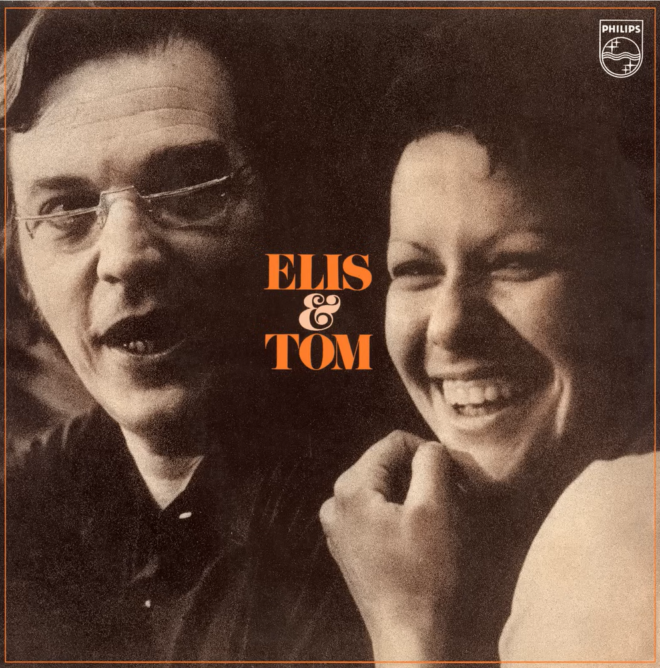

**Elis Regina**

Personal name Elis Regina Carvalho Costa

Born March 17, 1945

Died January 19, 1982

Frequently regarded as the greatest Brazilian singer of all time. She first married Ronaldo Bôscoli, later her long-time collaborator, pianist/composer/arranger César Camargo Mariano. Her untimely death from an accidental cocaine, alcohol and temazepam interaction at age 36, shocked Brazil.

16 **Garota de Ipanema** (**The Girl from Ipanema)** 5:24

***Stan Getz***-ts; ***Antonio Carlos Jobim***-p; ***Joao Gilberto***-g (voc on 2); Tommy Williams-b;

Milton Banana-dr; ***Astrud Gilberto***-voc.

New York, March 18-19, 1963.

LP Verve V6-8545 / CD 823 611-2.

<https://secondhandsongs.com/performance/4652> Astrud-engl. Only 2:48

<https://secondhandsongs.com/performance/1420307> Joao-portug, Astrud-engl 5:24

17 **Garota de Ipanema** (Girl from Ipanema) 2:39

***Antonio Carlos Jobim***-p, g; Claus Ogerman Orchestra, including Jimmy Cleveland-tb;

Leo Wright-fl, as; George Duvivier-b; Edson Machado-dr; unlisted strings; Claus Ogerman-

arr, cond.

New York, May 9-10, 1963.

LP Verve V6-8547 / CD 516 409-2.

**Os Cariocas**

Released July 1963

<https://secondhandsongs.com/performance/416317>

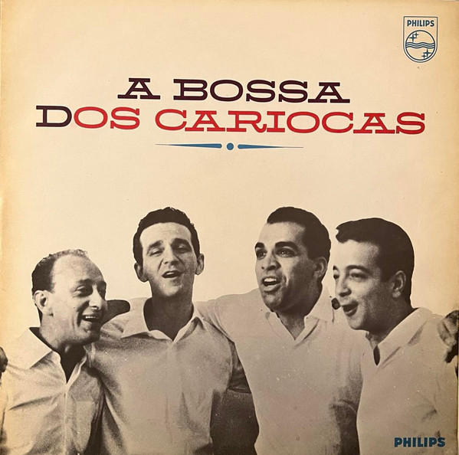 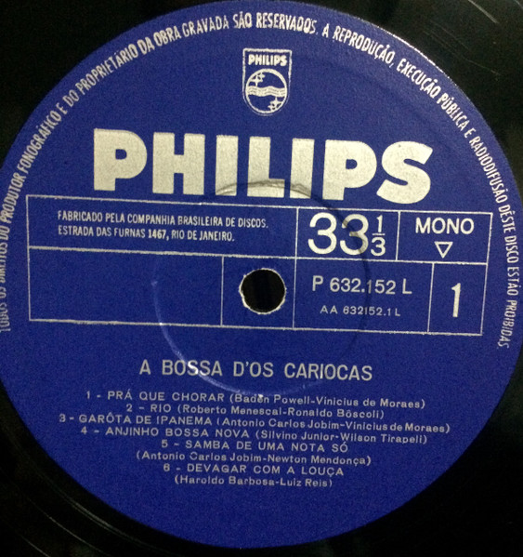

18 **The Girl from Ipanema** 6:34

***Stan Getz***-ts; ***Joao Gilberto***-g, voc; Gary Burton-vib; Gene Cherico-b; Joe Hunt-dr; ***Astrud***

***Gilberto***-voc.

Live at Carnegie Hall, New York, October 9, 1964.

CD Verve 823 611-2, 519 800-2.

**Oscar Peterson Trio**

October 19, 1964

<https://secondhandsongs.com/performance/195893>

19 **The Boy from Ipanema** 2:30

***Sarah Vaughan***-voc; ***Frank Foster Orchestra***: Wayne Andre, Billy Byers, Benny Powell,

Britt Woodman-tb; Richard Hixson-btb; Jerome Richardson-fl; Bernard Eichen, Lewis Eley,

Emmanuel Green, Leo Kruczek, Charles Libove, Gene Orloff, Tosha Samaroff-vio; Harry

Lookofsky-tenor vio; Bob James-p; Barry Galbraith-g; George Duvivier-b; Bobby

Donaldson-dr; Willie Rodriguez-perc; Frank Foster-arr, cond.

New York, August 13, 1964.

CD Mercury/Verve 549 374-2.

<https://secondhandsongs.com/performance/483728>

**Ella in Hamburg – Tommy Flanagan Trio = Boy from Ipanema**

March 26, 1965

<https://secondhandsongs.com/performance/1375144>

20 **The Girl from Ipanema** 8:37

***Archie Shepp***-ts; Ted Curson-tp; Joseph Orange-tb; Marion Brown-as; Reggie Johnson-b; Joe

Chambers-dr.

Englewood Cliffs, NJ, February 16, 1965.

CD Impulse! 11582.

<https://secondhandsongs.com/performance/405869>

**Frank Sinatra-Antonio Carlos Jobim**

January 31, 1967

<https://secondhandsongs.com/performance/18348>

Other versions

[The Girl from Ipanema](https://secondhandsongs.com/performance/62787) by [Antônio Carlos Jobim](https://secondhandsongs.com/artist/2280) released in August 1963   
[The Girl from Ipanema](https://secondhandsongs.com/performance/18348) by [Francis Albert Sinatra – Anto…](https://secondhandsongs.com/artist/319+2280) released in 1967   
[Girl (Boy) from Ipanema](https://secondhandsongs.com/performance/641823) by [Salena Jones with The Jobim's](https://secondhandsongs.com/artist/2280+15916+122571) released in 1994   
[The Girl from Ipanema](https://secondhandsongs.com/performance/1452676) by [Andy Williams with Antonio Ca…](https://secondhandsongs.com/artist/2033+2280) released in June 2005   
[The Girl from Ipanema](https://secondhandsongs.com/performance/590138) by [Antonio Carlos Jobim with Orc…](https://secondhandsongs.com/artist/2280+42127) released in April 1980   
[The Girl from Ipanema](https://secondhandsongs.com/performance/4652) by [Stan Getz & João Gilberto fea…](https://secondhandsongs.com/artist/2205+2280+3058) released in April 1964   
[Garota de Ipanema](https://secondhandsongs.com/performance/1081283) by [Tom Jobim part. Paula Morelen…](https://secondhandsongs.com/artist/2280+94151) released in 2000   
[Garota de Ipanema](https://secondhandsongs.com/performance/203692) by [Toquinho e Vinicius](https://secondhandsongs.com/artist/4673+59059) released in 1975   
[Garota de Ipanema](https://secondhandsongs.com/performance/439251) by [Vinicius con Maria Creuza y T…](https://secondhandsongs.com/artist/4673+59059+93917) released in 1970

[**Garota de Ipanema**](https://secondhandsongs.com/performance/6859) **by** [**João Gilberto, Antônio Carlos Jobim, Vinicius de Moraes**](https://secondhandsongs.com/artist/2280+3058+4673)

<https://secondhandsongs.com/performance/6859>

Performed live in [Um Encontro no Au Bon Gourmet](https://secondhandsongs.com/live-show/131) Concert August 1962

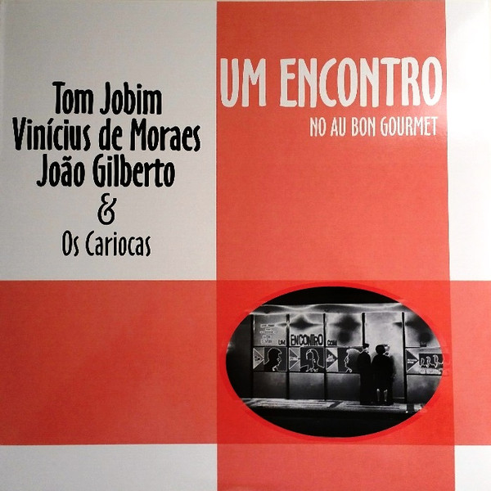 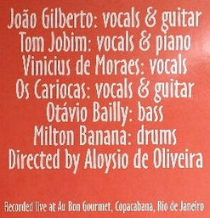

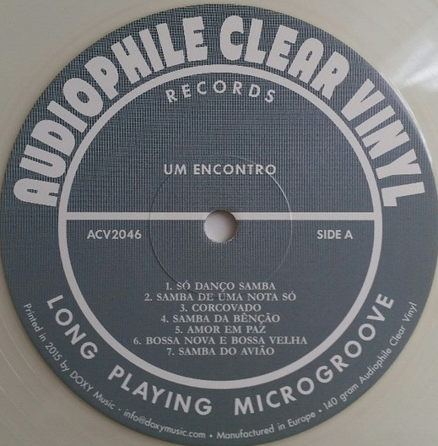 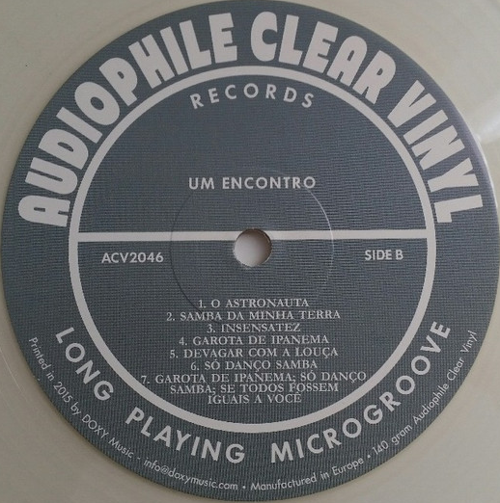

Bass – [Otávio Bailly](https://www.discogs.com/artist/639753-Octavio-Bailly-Jr)

Directed By – [Aloysio De Oliveira](https://www.discogs.com/artist/315790-Aloysio-De-Oliveira)

Drums – [Milton Banana](https://www.discogs.com/artist/14077-Milton-Banana)

Guitar, Vocals – [João Gilberto](https://www.discogs.com/artist/346760-João-Gilberto), [Os Cariocas](https://www.discogs.com/artist/80063-Os-Cariocas)

Piano, Vocals – [Tom Jobim](https://www.discogs.com/artist/27991-Antonio-Carlos-Jobim)

Vocals – [Vinícius De Moraes](https://www.discogs.com/artist/315789-Vinicius-De-Moraes)

Recorded live at Au Bon Gourmet, Copacabana, Rio de Janeiro in 1962.

Sold sealed with hand-written number on sleeve   
Limited to 500 copies.

|  |  |
| --- | --- |
| Label: | [Doxy](https://www.discogs.com/label/168208-Doxy) – ACV2046 |
| Series: | [Audiophile Clear Vinyl](https://www.discogs.com/label/1036413-Audiophile-Clear-Vinyl) |

Released in Europe 2015

**Vinícius de Moraes**

Personal name Marcus Vinicius da Cruz de Mello de Moraes

Born October 19, 1913

Died July 9, 1980

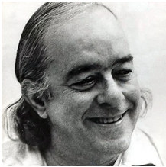 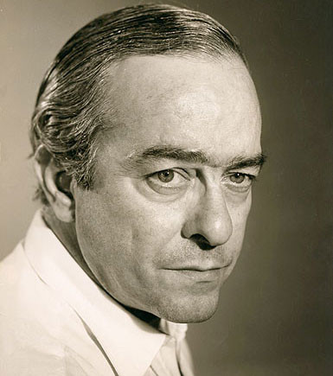

His presumed "full name", Marcus Vinicius da Cruz (d)e Mello Moraes, is apparently the result of a joke by Manuel Bandeira. According to de Moraes' sister, he was registered by his father as Marcus Vinicius de Moraes and then legally changed his name dropping "Marcus".  
Following the current Portugese orthographic rules, his name should be written as "Vinícius de Morais".

[22nd](https://secondhandsongs.com/explore/stats_most_covered_author?page=0) most covered composer/author  
[77th](https://secondhandsongs.com/explore/stats_most_covered_performer?page=0) most covered performer

Nicknamed "O Poetinha" (The Little Poet) Vinícius was a seminal figure in contemporary Brazilian music. As a poet, he wrote lyrics for a great number of songs that became all-time classics. Vinícius was also a composer of Bossa nova, a playwright, a diplomat and, as an interpreter of his own songs, he left several important albums.

**Os Cariocas**

Os Cariocas started their career in the 1940's, when Bossa Nova not even was dreamt of.   
From 1963 on they adopted the Bossa Nova aesthetic as a banner, helping popularize Brazilian music classics like 'Tem Dó', 'Tim-Tim-Por-Tim-Tim', 'Ela É Carioca' and 'Pra Que Chorar'. The group has had nine different formations before disappearing with the death of Severino Filho in 2016, one of its prime leader.

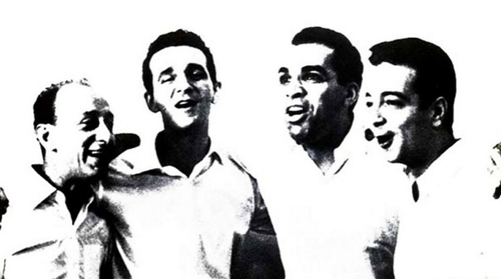

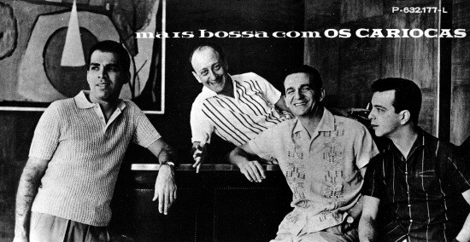

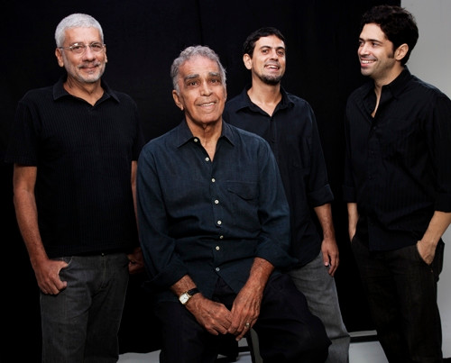

**Severino Filho**

Real name: Severino de Araujo Silva Filho

|  |  |
| --- | --- |
|  | Brazilian pianist, singer, composer, arranger and conductor.  Founding member of the legendary vocal group [**Os Cariocas**](https://www.discogs.com/artist/80063)**.**  Born in Belem, State of Pará, Brazil, in 1928.  Died on March 1st, 2016 in Rio de Janeiro, RJ, Brazil, aged 88. |

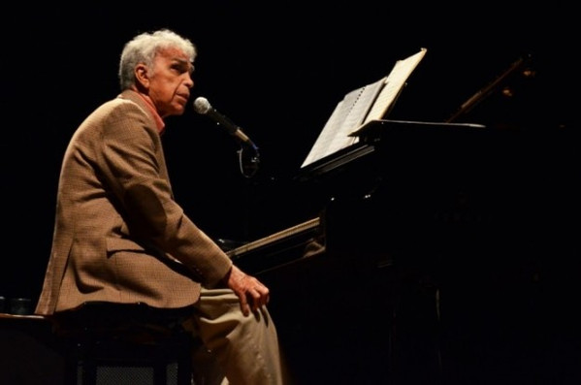

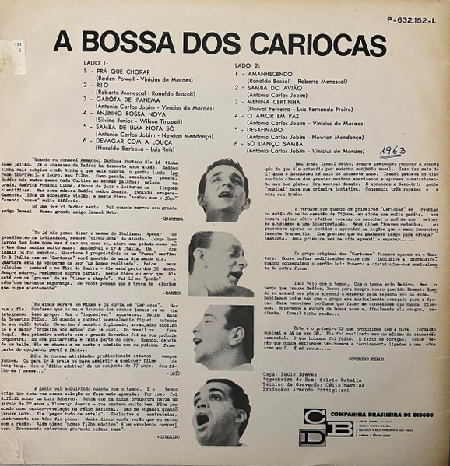

 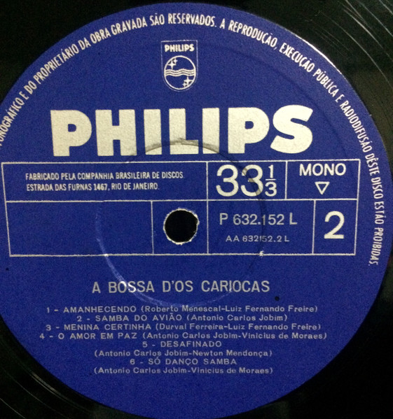

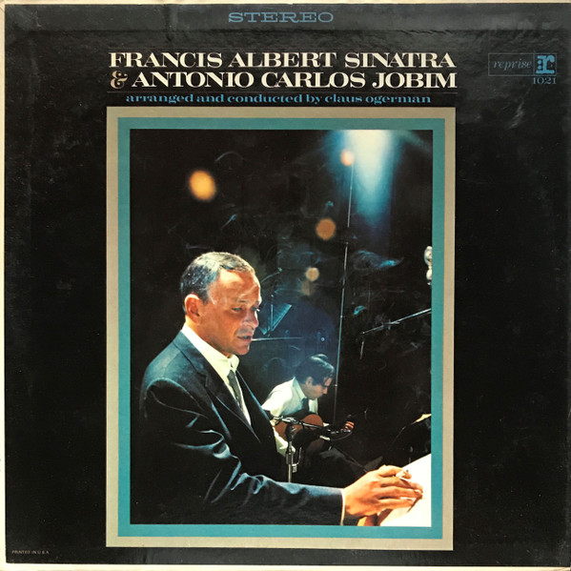

[**Francis Albert Sinatra & Antonio Carlos Jobim**](https://secondhandsongs.com/release/7508) **–** celé album

January 30 - February 1, 1967

<https://secondhandsongs.com/release/7508>

Francis Albert Sinatra & Antonio Carlos Jobim is a 1967 studio album by Frank Sinatra, featuring Antonio Carlos Jobim.   
The tracks were arranged and conducted by Claus Ogerman and his orchestra.   
Along with Jobim's original compositions, the album features three standards from the 'Great American Songbook', ("Change Partners", "I Concentrate on You", and "Baubles, Bangles and Beads") arranged in the bossa nova style.   
Sinatra and Jobim followed up this album with sessions for a second collaboration, titled Sinatra-Jobim. That album was briefly released on 8-track tape in 1970 before being taken out of print at Sinatra's behest, due to concerns over its sales potential. Several of the Sinatra-Jobim tracks were subsequently incorporated in the Sinatra & Company album (1971) and the Sinatra-Jobim Sessions compilation (1979). In 2010 the Concord Records label issued a new, comprehensive compilation titled Sinatra/Jobim: The Complete Reprise Recordings.   
At the Grammy Awards of 1968 Francis Albert Sinatra & Antonio Carlos Jobim was nominated for the Grammy Award for Album of the Year.   
Recorded: January 30 - February 1, 1967, Hollywood, Los Angeles.