As we all know, Fifty Shades of Grey, originated as a piece of fanfic based on the Twilight
Fanfic = fiction written by fans of another book/tv series/film
Fiction / non-fiction
series. Since it hit 31 million sales in 37 countries worried voices are asking: is this the beginning of an era in which fanfic overthrows original creation?
To overthrow = dělat převrat
It's tempting to get caught up in paradigm-shift
Shift = posun
apocalypticism, but a closer inspection reveals that fanfic is not new at all. There have been phases, fads, peaks and controversies throughout its history and it displays an incredibly
fad = the latest fashion
diverse range of sub-genres. There's crossover, AU, Hentai, OoC, Uber, Mary Sue, slash fic, hate fic, anti fic and even wing fic (in which familiar characters sprout wings and discover their new beauty through acts of mid-air coitus). So where did this terrifying range of forms begin? And is Fifty Shades really a threat to culture?
Threat = hrozba
It's time to learn some of the jargon that fans use to describe their fic.

Folklore fanfic
If one sees fanfic as "the work of amateurs retelling existing stories", then one would have to conclude that the number one book in the middle ages – the Bible – was a work of fanfic, as Matthew, Mark, Luke and John were non-professionals retelling the same story about the same character. However, such a definition of fanfic is skewed historically. There were no
To skew = deformovat
fans in the middle ages, and there were also no authors.
If we see fanfic as "the reworking of another author's characters" then this form really only appears for the first time in history with the invention of legal authorship in the 18th century through copyright and intellectual property laws, after the invention of the printing press.
Printing press = knihtisk
Derivative = neoriginalní
Oral = mouth
Aural = ears
After all, you can't have derivative works or copies if there are no regulations over what constitutes original works, or separates ownership from theft. Predating this change, with the
Thief = zlodej
Theft = kradez
exception of educated men of letters and Christian scholars, the populace experienced stories only through the aural folklore tradition. Such tales were re-tellings and re-makings of the same stories over generations – this was a manuscript culture in which texts were open to intervention and were not fixed. Nobody owned them and they were based on stock characters
stock character = ustalene postavy
rake = milovnik
royalties = tantiemy
– The rake, the temptress, the Stephron and the Phyllis (Shepherd & Shepherdess), the priest, the devil, the good Samaritan. In England, The Romance of the Rose was the paradigmatic example of the medieval form: one writer would begin the story and another would complete it. Even Shakespeare, did not own the stories in his plays. A patron would commission him to retell a story and he was paid in royalties. All stories within the medieval period were re-workings of stories about the same characters, but we could not call them fanfic as copyright law and the printing press had not yet sectioned off the professional, paid, copyright owner of original texts, from the rest of the populace, creating a subclass of fans.

Fifty shades of Austen

Courtship = dvoreni se

Court = dvur

Courteous = zdvorily

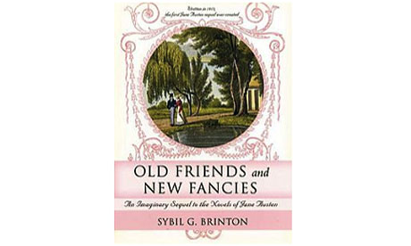Old Friends and New Fancies – an Imaginary Sequel to the Novels of Jane Austen by Sybil Brinton

No sooner had …….. than = Sotva (vznikl roman)
No sooner had the novel emerged in the 18th century than popular authors such as Daniel Defoe started protesting that his work was being "kidnapped" and bowdlerised by amateur writers who reduced the value of his creations with inferior impersonations. Jane Austen was less concerned with such matters, basing characters like Wickham in Pride and Prejudice upon "The Rake" from the lore tradition. In the 20th century with developments in cheap printing techniques and distribution, Austen inspired fanzines. A cult of dedicated literary
Fanzine = magazine for fans of something
fans called themselves the Janeites and the novel Old Friends and New Fancies – an Imaginary Sequel to the Novels of Jane Austen by Sybil Brinton, published in 1913 was the first published work of Austen fan fiction. This is an example of continuation fic – the creation of storylines that use the same characters but elaborate on unresolved threads within the originals to create new episodes. A century later the Jane Austen Fanfiction Index now catalogues over two hundred thousand works of Austen fanfic, while Goodreads currently lists 242 published books of fanfic derived from Austen. Titles include Vanity and Vexation and Dating Mr Darcy. A great number of Austen fanfic stories are pornographic.

The strange case of Sherlock & Mary Sue
In the 1920s, fans of Conan Doyle started Sherlock Holmes societies in London and New York, at which they debated issues such as the question of whether Holmes's addiction to cocaine was beneficial to his perception or a sign of moral weakness. They also produced the
Beneficia = prospeSny
Baker Street Journal, a hybrid zine, halfway between scholarly research and pure fandom and at gatherings read their own versions of stories they'd written themselves. The most notable works are examples of self-insert fic – in which the writer meets their hero. Examples include: My First Meeting with Sherlock Holmes by Ellery Queen and Sherlock Holmes in the White House by Roosevelt. Roosevelt in this case was not the then President, so this was also real person fic – in which a fan writes about politicians, sports celebrities, musicians, film stars etc, as if they are known to them – with self-insert.
When the self-insert character is the author thinly disguised this is called Mary Sue fic. Mary Sues are usually flawless characters who outshine the famous characters they are placed beside. In 1973, one Paula Smith wrote an infamous fanzine short story: A Trekkies Tale in which the Starship Enterprise was visited by someone called Paula – a stunning woman who all the crew fell for. By the late 1980s there had been a glut of Mary Sues fictionally beaming themselves up on to the Starship Enterprise, and true fans started to view the sub-genre plots as insidious. Interestingly, by outshining the heroes Mary Sues reveal a lurking contempt on behalf of their fan writers towards the original characters.

The Enchanted Duplicator
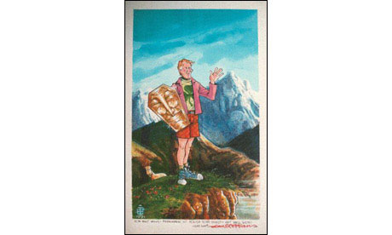Original cover for The Enchanted Duplicator
From the 1930s to 50s fanfic existed almost exclusively within the sci-fi communities, in clubs such as the Futurians (1937–1945). A fascinating bunch, obsessed with communism and latterly fascism). Many fans from such groups, such as, Isaac Asimov, went on to become published authors, blurring the distinction between amateur fan and professional writer. In 1952, the world's first book of fanfic about fans appeared. The Enchanted Duplicator by Walt Willis and Bob Shaw was a metafiction based on Bunyan's The Pilgrim's Progress, but which described a world populated with sci-fi fans. It chronicles the adventures of hero Jophan in "the land of Mundane". All of the characters in the book are renamed versions of real fans from the London SF circle of the 50s and the book was created entirely for their pleasure. The Enchanted Duplicator of the title is a mimeograph – a precursor to the photocopier and the chosen distribution medium of the fan. The book concludes with Jophan's discovery of "The Magic Mimeograph" which "… will produce the Perfect Fanzine … and now the song of the trumpets filled the air, ringing across Trufandom to the far mountains". This is fanfic squared and a way of life called "fandom".

Slash and K/S
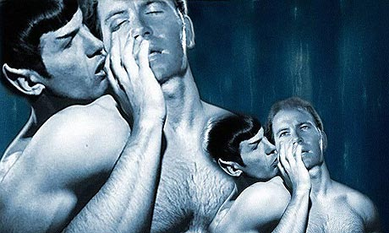Desert Heat – Spock and Kirk by Gayle Feyrer
With the growth of television in the 50s fanfic spread globally. Sci-fi fanfic then morphed and its subtexts became dominant. Slash fic is sub-genre in which buddies from classic TV become gay lovers. The first slash fic novel to be published was The Ring of Soshern, a 105-pager by Jennifer Guttridge (1968). In it Spock and Kirk find themselves stranded on a remote, deserted planet. Spock goes into the state of "Pon Far": the violent "on heat" fever that comes to Vulcans, during which they must "have sex or die". To save Spock's life Kirk allows Spock to penetrate him, the two then fall in love and "spend all their remaining days on the planet exploiting both the planet and each other's bodies".
Exploit = vyuzit
The violent-sounding "slash" is so called because of the "/" separating the names of the two characters involved in homoerotic love or pornographic sex, for example Holmes/Watson, Spock/McCoy, Harry Potter/Ron, Starsky/Hutch, Jesus/Judas. Over the decades slash has also come to stand for porn of any kind, including "Het". Other subgenres in slash include femslash in which formerly het characters have lesbian experiences (Buffy is popular). HP femslash is Harry Potter lesbian porn; real person slash is where the writer makes love to a famous person; and, disturbingly, Chanslash is a Japanese sub-genre which involves coitus with famous characters who are underage. These two merge in Justin Bieber fanfic. On one site alone there are 16,040 stories available as ebooks by 8,028 authors, which feature the child star at different ages and to degrees of eroticism. The story 1st by Cassie Chassey is a Self-insert Mary Sue Het Slash romance which includes "emotional abuse, sexual abuse and sexual assault".
We are four = je nam 4 roky
There are 4 of us = je nas 4

End of work on 16.2.15 ☺
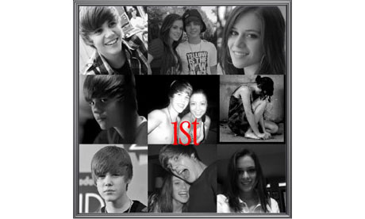1st by Cassie Chassey
Undercurrent = spodní proud
There is a dark sexual undercurrent to the majority of fanfic, as if on a subconscious level the fan actually resents the control that their idol or idealised character has over their life. Through the act of writing fanfic, and subjecting characters to compulsive or vengeful love, sex, S&M or rape, the fan then regains control.
To subject someone to something = podrobit nekoho necemu
Resent = nesnaset
Revenge = pomsta
Vengeful = pomstychtivy
Subconscious = podvedomi

James Potter and the prisoner of copyright
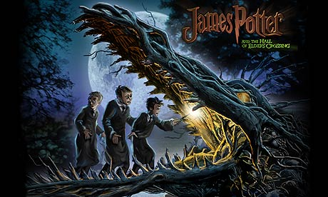
Split = rozdelene
To dilute = zredit
Vigorously = silne
To claim = tvrdit
Threaten = ohrozovat
While fanfic multiplied exponentially with the invention of the internet, authors were split over what to do about it. Anne Rice, author of Interview with the Vampire vigorously defended her copyright, claiming that fanfic, in particular AU fic diluted the integrity of her characters and stories. In a letter to her fans she stated: "I do not allow fan fiction. The characters are copyrighted. It upsets me terribly to even think about fan fiction with my characters. It is absolutely essential that you respect my wishes." Fanfic authors then claimed that Rice had attacked them by email and even threatened their businesses. She also demanded that FanFic.net remove all fanfic stories. Since then authors such as Andre Norton, Mercedes Lackey and David Weber have also come to adopt a zero-tolerance stance.
Stance = postoj
Encourage = povzbudit
Flatter = lichotit
Stipulace = prikazat
Contrary to this Douglas Adams claimed that fanfic expanded his understanding of the parallel universes he'd created in The Hitchhiker's Guide to the Galaxy and that they increased his sales. JK Rowling also encourages fanfic. In 2003 she said she was "flattered people wanted to write their own stories" based on her characters. She did however stipulate one condition – that they did not try to make money from their creations. Her stance was tested when fan/author George Lippert decided to commercially release a book of Continuation fic which was Extending the Canon. James Potter and the Hall of Elders' Crossing was based on a fictional son of Harry. Rowling threatened legal action for infringement, but after much adverse press from fans she relented and allowed the publication to go ahead.
To infringe = nerespektovat autorska prava / patent
Disclaimer = pozorovani/prohlášeni
Proviso = condition / podmínka
futile = marny
Fans now use disclaimers such as: "JK Rowling owns all recognisable characters/settings/spells/etc in this fanfiction." And Rowling permits all fanfic under the proviso that it does not contain racism or pornography. This an entirely futile request as slash HP (Harry Potter) has become one of the internet's most popular fanfic forms. In it Rowling's characters are made to have sex with each other in almost infinite variations: Harry/Ginny, Ron/Hermione, Snape/Narcissa. Arthur/Molly, Molly/Hermione, Hermione/Fred&George, Draco/Pansy. These have also been "crossed-over" with characters from other films and books, some of which are paedophilic in nature. Such quantities of posts are nearly impossible to track and monitor. Fan fiction.net has 603,410 HP fic stories.
Rowling's launch of Pottermore online is set only to increase fan participation and produce even greater quantities of fanfic, including slash. There is even fanfic about Pottermore.

Crossing over and mashing up
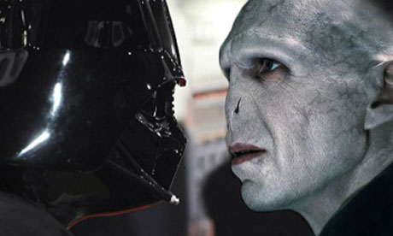Darth Vader & Spongebob VS Edward & Harry Potter
The most postmodern and aesthetically bankrupt of all fanfic, is when two well-known franchises from the same genre are "crossed over". So you get BattleStar Gallactica, crossed with Star Trek, which results in the story: Star Trek: Way of the Battlestar – author Carson Napier.
One of the problems with this sub-genre is that narratives and character motivations have to be warped to fit convoluted, meaningless mergings. This is taken to absurd lengths with YouTube "films" like Battlestar Galactica Vs Star Wars Vs Star Trek Vs Babylon 5. Crossover has now become mainstream through such projects as Aliens Vs Predator which exists as cartoons, computer games, movies, a TV series and a series of novels. Crossover also jumps genres so Edward from Twilight ends up in Hogwarts, Bella ends up in ER and the characters of The X-Files clash with those of Breaking Dawn.
While much credit has been given to mashup author Seth Grahame-Smith for "unleashing a whole new genre", with mashup, the truth is that the mashup technique behind Pride and Prejudice and Zombies, was developed decades before within fanfic. The aesthetic innovation that elevates mashup fic above Crossover fic is the deliberate clash of incompatible genres in a way which is deconstructive or at least humorous, as in Abraham Lincoln Vampire Hunter.
Much mashup fanfic however simply creates an incomprehensible mess. See A Very Potter Sitcom, season 2! In which Dumbledore appears in Legally Blonde the Musical and the Triwizard mashup in which fans vote for fight stories to be written between characters such as Godzilla, Gandalf, Darth Vader and Spongebob Squarepants. This also results in meaningless second gen multiples like Darth Vader & Spongebob VS Edward & Harry Potter. Fanfic sites also post narratives of impossible meetings (usually sexual) between improbable characters – Captain Jean-Luc Picard has sex with Elrond from Lord of the Rings. Indiana Jones has sex with Voldemort – this is mashup slash. As no new plot or characters are being created, then all that can happen is the multiplication of crossover interactions and partners, and an attendant increase in sexual imagery and violence. There are literally millions of fanfic stories in which sex and humiliation (fuelled no doubt by fan boredom) are the only possible outcome of such contrived and meaningless confrontations.

Alternative Twilight universes
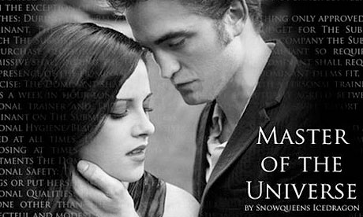Master of the Universe by Snowqueens Icedragon
Since the 90s AU has dominated. AU fic (alternative universe) features stories which are based on "what-ifs", which deviate from the original novels or films. So there's "What if Darcy was blind" or "What if (in Twilight) Bella is engaged, to Jasper, not Edward". The stories must deviate from the canon but still remain familiar. There are currently over a hundred self-published Twilight AU novels, while fanfiction.net has 130,137 predominantly AU narratives which include: Edward and Bella meeting in kindergarten; Edward as a teacher, Bella as a student (with motorbike action); Jacob and Edward as gay lovers; Bella and Alice in love; Edward is an Angel; Bella is the vampire and Edward is the human; Bella is a millionaire and Edward is a professional thief; Edward is a tattoo artist; Bella is on the Titanic; Bella is going to commit suicide when sexy teacher Cullen saves the day; Bella owns a Pizza place called Pizza and Porn; Edward and Bella set in the 1800s (a rape fantasy). On this site 66,606 of the stories are rated M, for 18+. As one leading fanfic site claims, "the majority of Twilight fanfic is porn". Many of these stories will sound spookily familiar. In one: His Personal Assistant (2009), "Bella Swan, personal assistant to handsome, rich, successful Edward Cullen, decides to make oblivious boss fall in love with her"; in another (2009) "Edward is a millionaire obsessed with Isobella Swan". One, The Submissive by Tara Me Sue, is described as "37 chapters of juicy graphic detail", "Think Story of O meets Twilight minus the vampire stuff". This story, which can be found on fanfiction.net, like the others above, predates the publication of Fifty Shades by two years and was not written by EL James.

50,000 shades of lore
Fifty Shades series grew out of a multi-part series of Twilight fanfic called Master of the Universe. It placed the Bella and Edward love affair in an alternative universe, in contemporary Seattle and changed their names: Bella = Anastasia, Edward = Christian Grey.
Although the author then tried to erase evidence of its fanfic origins, it's clear that rather than being some lightning bolt new genre called "Mommy porn", Fifty Shades is actually a very generic work of Twilight fanfic from amongst tens of thousands already created. It is, in fact, a piece of "AU het slash Twilight fic", and as we've seen, in all slash fic, sex and sexual violence are the predictable components of the genre.
We should not consider EL James an author in the conventional sense for the same reasons that we wouldn't call someone from before the invention of copyright an author. Rather, her books are like medieval lore – in a sense she doesn't own the content. This content was circulating in 60,000 variations among the fanfic of other Twilight fans for years before she even created the books. Like a gambling machine with a limited number of options for recombination, the story was going to eventually be spat out as a win for somebody. This isn't an example of plagiarism but a return to an earlier notion of collective creation. Fifty Shades is a book with 60,000 authors.
The only innovation is not in the story itself but in the delivery system that launched it – Amazon KDP. Without Kindle the book(s) would never have escaped the gravitational pull of fanfic sites and would not have been able to earn their author any money. KDP, has become the Enchanted Duplicator that has monetised fanfic and propelled it into the market. The historic difference, the point we have just crossed, is that now, through the mechanism of epub, fanfic is heading towards becoming the cultural dominant. The much-hyped "next Fifty Shades", Gabriel's Inferno, also started life as Twilight fanfic, and the fact that Penguin hunted it down from fanfic sites and paid a "seven-figure" sum, marks the transition where the market turns upside down, and mainstream content is created by fans.
Beyond that, as we have seen with other fanfic, Fifty Shades has launched a spate of impersonations, pastiches, parodies, homages and rip-offs. Like the Enchanted Duplicator, this is fanfic based on fanfic. Currently on Amazon there are 641 quickly made ebooks tagged under "Fifty Shades". They fall into the hate fic, insert fic, crossover fic and continuation fic categories and include: Fifty Shades of Earl Grey, Fifty Shades of Garbage, Fifty Shades of Bacon Flavoured Vagina Spray, Fifty Shades of Grey and Zombies, Fifty Shades of Pink, of Green, of Gay, of Alice in Wonderland, of Twilight. Finally with Fifty Shades being developed by Universal Pictures the phenomenon comes full circle. If any of the stars of Twilight the Movie appear in Fifty Shades the Movie, then the serpent will have devoured its tail.

So what happens to culture when fanfic becomes the dominant economic model in publishing and the leader in cultural values – is that even possible? Surely derivative works have to be derived from something "original". With Fifty Shades this ceases to be the case, and, as we have seen, fanfic offers many tools for recycling (AU, crossover, mashup, self-insert, Mary Sue, the 12 varieties of slash etc) which takes the recombination of texts into the exponential. It is possible that with the enchanted duplication systems of fan-based epub, we might have arrived at a point in history where we've accumulated enough cultural material from the past for fans to remix indefinitely, and as they can now sell this content to each other this becomes a boom industry where none existed before. However, the point where fans become the creators, and a derivative work becomes the new original is also the point at which the culture industries stop needing to create anything new. Fanfic begets fanfic, which then in turn becomes mainstream which then begets further fanfic and so on. When we reach that point our future will not be fifty, but fifty thousand, shades of grey.

